## PRACTICUM PORTFOLIO

In partial fulfillment of

the requirement for the course of Hospitality Management Services

MORALITA, PAOLO VINCE C AUGUST 2023

## REPORT AND DOCUMENTATION PRACTICUM TRAINING

1

Submitted by:

MORALITA, PAOLO VINCE C

## HOSPITALITY MANAGEMENT SERVICES

Submitted to:

### Jonel M. Rafol

Student Internship Program, Coordinator

2nd Semester

S.Y 2023-2024

2

## TABLE OF CONTENT

1. **INTRODUCTION**

### COMPANY PROFILE (Host Training Establishment)

* 1. Mission & Vision
  2. Organizational Chart
  3. Staff and Personnel
  4. Outstanding Characteristics of Company (Best Features)
  5. Pictures of Physical Facilities

### ESSAY (My Journey as A Future Course)

1. **APPENDICES (Attachments)**
   1. Practicum Pictures
   2. Pre-Internship Requirements
      1. Certificate of Undertaking
      2. Updated Certificate of Grades and/or Evaluation Form
      3. Certificate of Registration/Enrollment Form
      4. Photocopy of School I.D
      5. PSA Birth Certificate/Marriage Contract (Married Women students)
      6. Parent/Guardian/Spouse Consent Form
      7. Medical Certificate (Issued by School Clinic)
      8. Practicum Recommendation Letter
   3. Post-Internship Requirements
      1. Practicum Weekly Report (Once a week meeting w/Practicum Faculty-in-charge)
      2. Practicum Daily Time Record
      3. Practicum Incident Report (if Applicable)
      4. Industry Performance Evaluation Form
      5. Narrative Journal Report with Photos in Action
      6. Post Practicum Survey Form (to be issued by the APA Office)
      7. Certificate of Completion
   4. Curriculum Vitae (CV)

3

**ACADEMIC AFFAIRS AND RESEARCH**

**INSTITUTE OF MANAGEMENT AND BUSINESS ALLIED PROFESSIONS**

**PRACTICUM REQUIREMENTS ACADEMIC YEAR 2023-2024**

**I. PRE-INTERNSHIP REQUIREMENTS CHECKLIST**

All requirements must be completed and submitted prior to the Practicum schedule. Students with incomplete requirements will not be accommodated.

|  |  |  |  |
| --- | --- | --- | --- |
| **REQUIREMENTS** | **COMPLIED** | **NOT**  **COMPLIED** | **REMARKS** |
| 1. Attendance to the Practicum Orientation | ✔ |  |  |
| 2. Certificate of Undertaking / Letter of Intent | ✔ |  |  |
| 3. Curriculum Vitae with 2x2 Picture (Plain white background) | ✔ |  |  |
| 4. Updated Certificate of Grades and / or Evaluation Form for CHED / TVET program (To be issued by Registrar) | ✔ |  |  |
| 5. Certificate of Registration / Enrollment Form (To be issued by Registrar) | ✔ |  |  |
| 6. Photocopy of School ID | ✔ |  |  |
| 7. PSA Birth Certificate  Marriage Certificate (for married women students) | ✔ |  |  |
| 8. Parent / Guardian / Spouse Consent Form (Attach photocopy of Parent’s valid ID with Specimen Signature) | ✔ |  |  |
| 9. Medical Certificate (To be issued by the School Clinic) with Covid Vaccine Card | ✔ |  |  |
| 10.Practicum Recommendation Letter | ✔ |  |  |

4

*\*****NOTE****: Memorandum of Agreement will be issued by the Office of the Extension and Linkages to the Industry / Host Training Partner.*

## POST-INTERNSHIP REQUIREMENTS CHECKLIST

Post Requirements are to be collated and submitted during and after the completion of Practicum*.*

|  |  |  |  |
| --- | --- | --- | --- |
| **REQUIREMENTS** | **COMPLIED** | **NOT**  **COMPLIED** | **REMARKS** |
| 1. Weekly Reporting (once a week meeting with Practicum Faculty-in- Charge) | ✔ |  |  |
| 2. Practicum Daily Time Record | ✔ |  |  |
| 3. Practicum Incident Report (if applicable) | ✔ |  |  |
| 4. Industry Performance Evaluation Form | ✔ |  |  |
| 5. Narrative Journal Report with photos in action | ✔ |  |  |
| 6. Post Practicum Survey Form (To be issued by the APA Office) | ✔ |  |  |
| 7.Certificate of Completion | ✔ |  |  |

5

## INTRODUCTION

Before, the City Government of Parañaque has no existing public higher education institution to cater the formal educational and training requirements needed by its constituents. Now, the city has established a higher learning institution to respond and supply the demand of the city’s growing economy by providing a free and formal educational development and training needs. Thus, the creation and the birth of Paranaque City College (PCC).

Through the combined efforts of Honorable Mayor Edwin L. Olivarez; Vice Mayor Rico T. Golez; Congressman Eric L. Olivarez of 1st District; Congressman Gustavo Tambunting of 2nd District; Councilor Maritess B. De Asis, Chairwoman of Committee on Education; and the City Councils namely; Florencia N. Amurao, John Ryan G. Yllana, Vincent Kenneth M. Favis, Victor Eriko M. Sotto, Giovanni E. Esplana, Merlie S. Antipuesto, Jacqueline Bustamante-Mendoza, Rufino M. Allanigue, Joan A. Villafuerte-Densing, Ricardo L. Baes Jr., Jason P. Webb, Brillante V. Inciong, Roselle Nava-Tan, Raquel Gabriel-Velasco, Jeremy S. Marquez, and Vanessa Alma Moreno-Lacsamana. Paranaque City College (PCC) was established and created as a technical-vocational education institution by virtue of the City Ordinance No 14-02 series of 2013 enacted last February 6, 2014.

Further, a resolution authorizing PCC to offer 6-month Technical-Vocational Training Courses as an institution providing skills training and development was passed and issued through a Resolution No. 14-084 Series of 2014 last May 29, 2014. Short courses included in the resolution to offer are the: Front Office Services NC II; Contact Center Services NCII; Bookkeeping NCIII; Housekeeping NCII; Food and Beverage Services NCII; Cookery NCII; and Local Guiding Services NCII. However, PCC officially started offering short programs in Bookkeeping NCIII, Housekeeping NCII, and Food and Beverage Services NCII on September 16, 2014. These are the short programs being offered to meet the mounting demands of the growing industrial and commercial establishments in the city.

Moreover, to open up for more employment opportunities for fresh graduates with the emergence of world-class hotels, resorts, casinos and other entertainment establishments along the bay area of Paranaque, PCC also offered a 2-year diploma program on Hotel Management Services which was granted approval by TVET last 2017. The creation and establishment of this institution gives benefits to the poor constituents of the city in terms of educational opportunities and developments.

With its mission of giving academic excellence and help provide the growing industrial and commercial sectors of the city – the needed professional human resources in the future, Honorable Mayor Olivarez did not stop opening avenues to provide his citizens what the latter need most. He has thought of adding formal baccalaureate programs to be offered to the city’s constituents. PCC added CHED programs and is now operating as the newest and the first formal public higher education institution in the city. PCC gained and acquired its initial permit to offer tertiary programs from the Commission on Higher Education (CHED) last June 26, 2019, thus started officially as the first formal public higher education institution in the city last August of school year

2019-2020 offering three college programs in: Bachelor of Science in Entrepreneurship, Bachelor of Science in Tourism Management, and Bachelor of Science in Real Estate Management.

6

## COMPANY PROFILE

* 1. **Vision & Mission**

## VISION

one of the premier locally funded higher educational institution in the metro south provides accessible, innovative and relevant quality higher education

## MISSION

Parañaque City College is committed to provide, serve and educate its stakeholders a research-based and student centered learning experiences through relevant responsive and innovative competencies in pursuit of the highest quality of life possible to all Parañaque City residents

### Organizational Chart

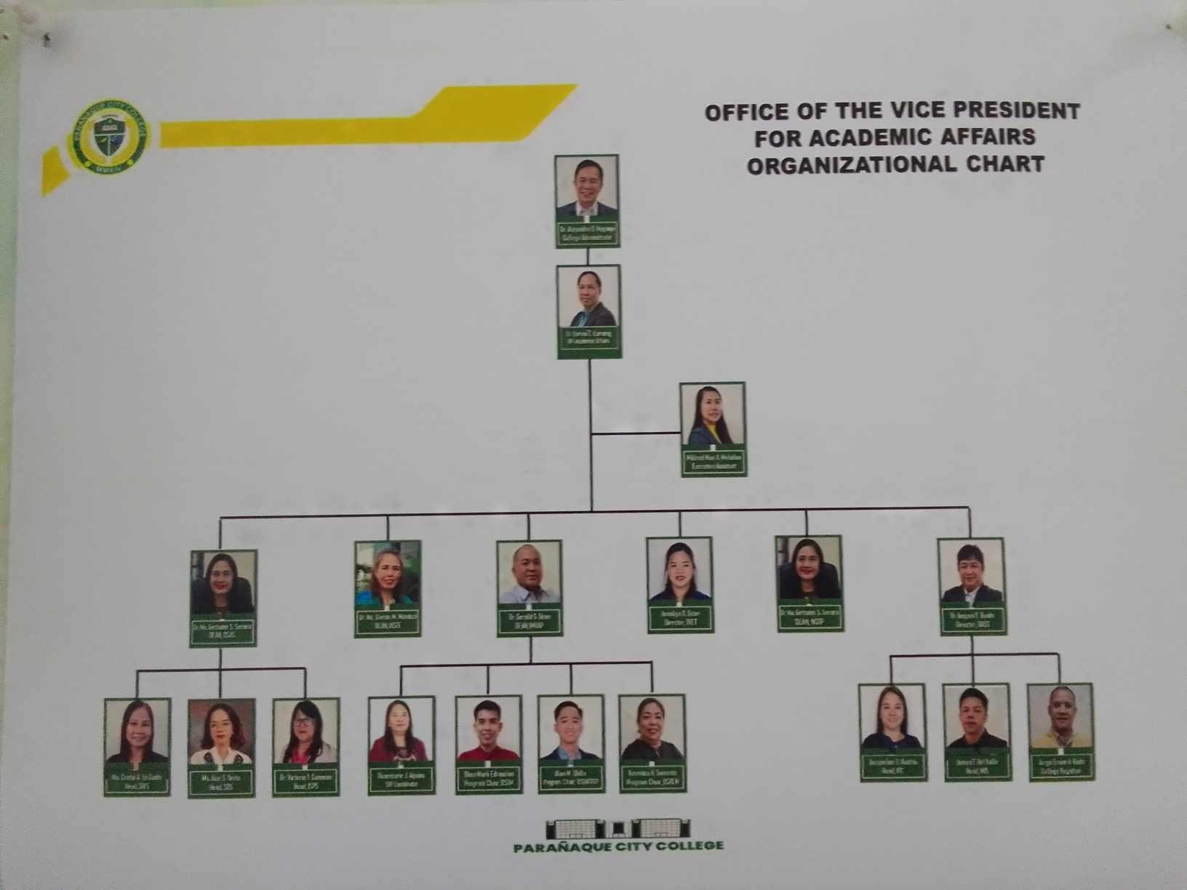

7

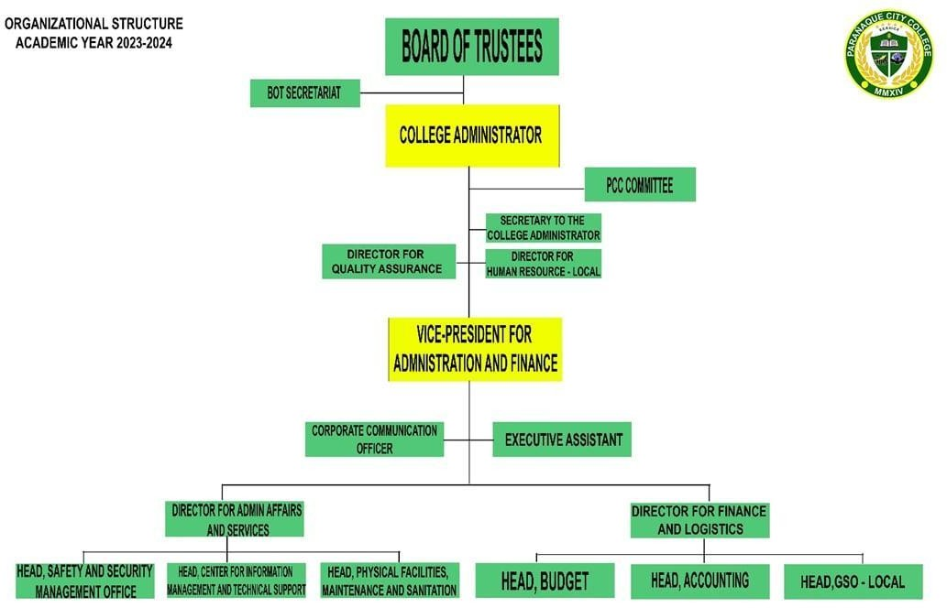

### 8

* 1. **Staff and Personnel (Department Assigned only)**

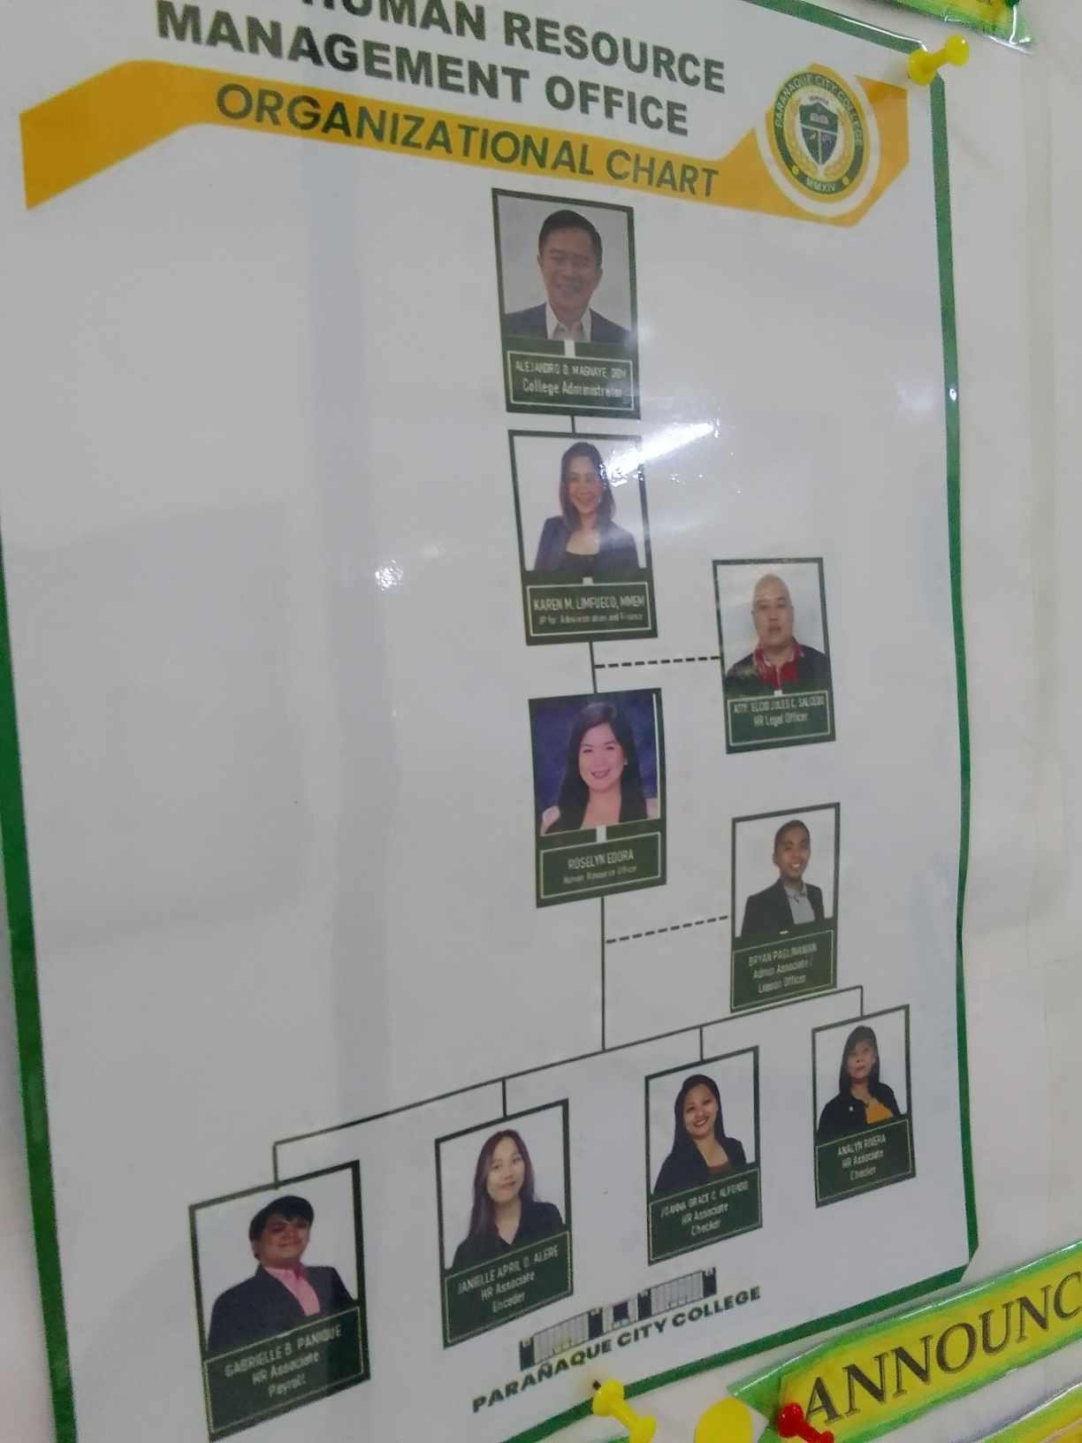

9

### Outstanding Characteristics of Company (Best Features)

~Communication

~Customer Focused

~Engagement

~Teamwork

~Health

~Passion

~Leadership

~Priorities

~Transparency

10

### Pictures of Physical Facilities

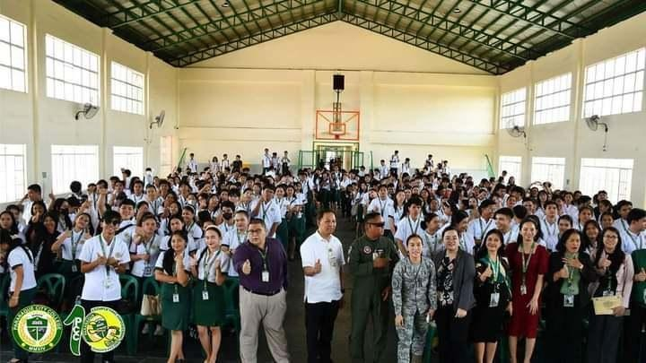

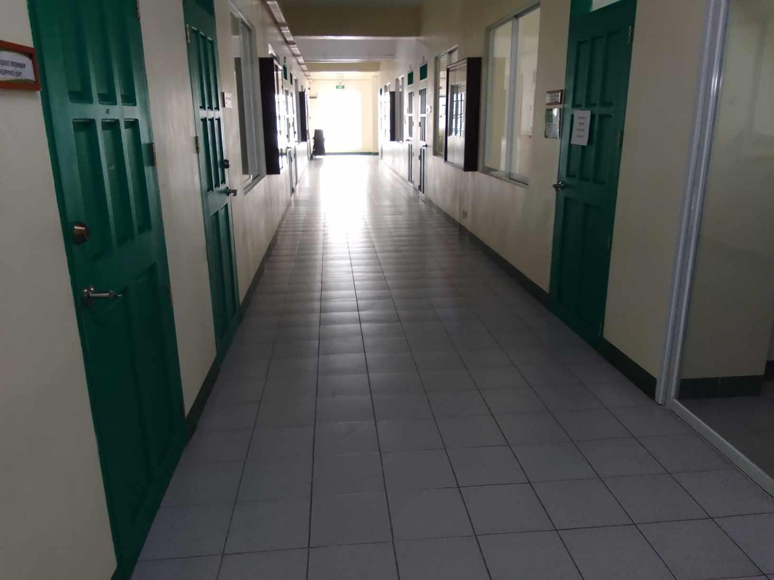

11

### ESSAY (My Journey as A Future Course)

It's not as easy as I had anticipated to start this journey. I had assumed that everything would become easier if I put in the necessary dedication and determination. I wanted to complete my work quickly, but I neglected to consider my objectives and the reasons behind my choices.

My trainers are all highly effective and efficient since they have taught me many valuable skills that I will

need to keep in mind while I work in the future. I need to be knowledgeable about everything, even the most fundamental things, in order to give my customers high-quality services.

I am aware that I am in the middle of the road in this industry, and when I am committed to what I am doing, I can achieve more.

I know there will be more possibilities when I have perseverance and drive in my quest, so I want to

appreciate the times I have left. I will be professional when it comes to making my ambitions come true.

12

### APPENDICES (attachment)

* 1. **Practicum Pictures**

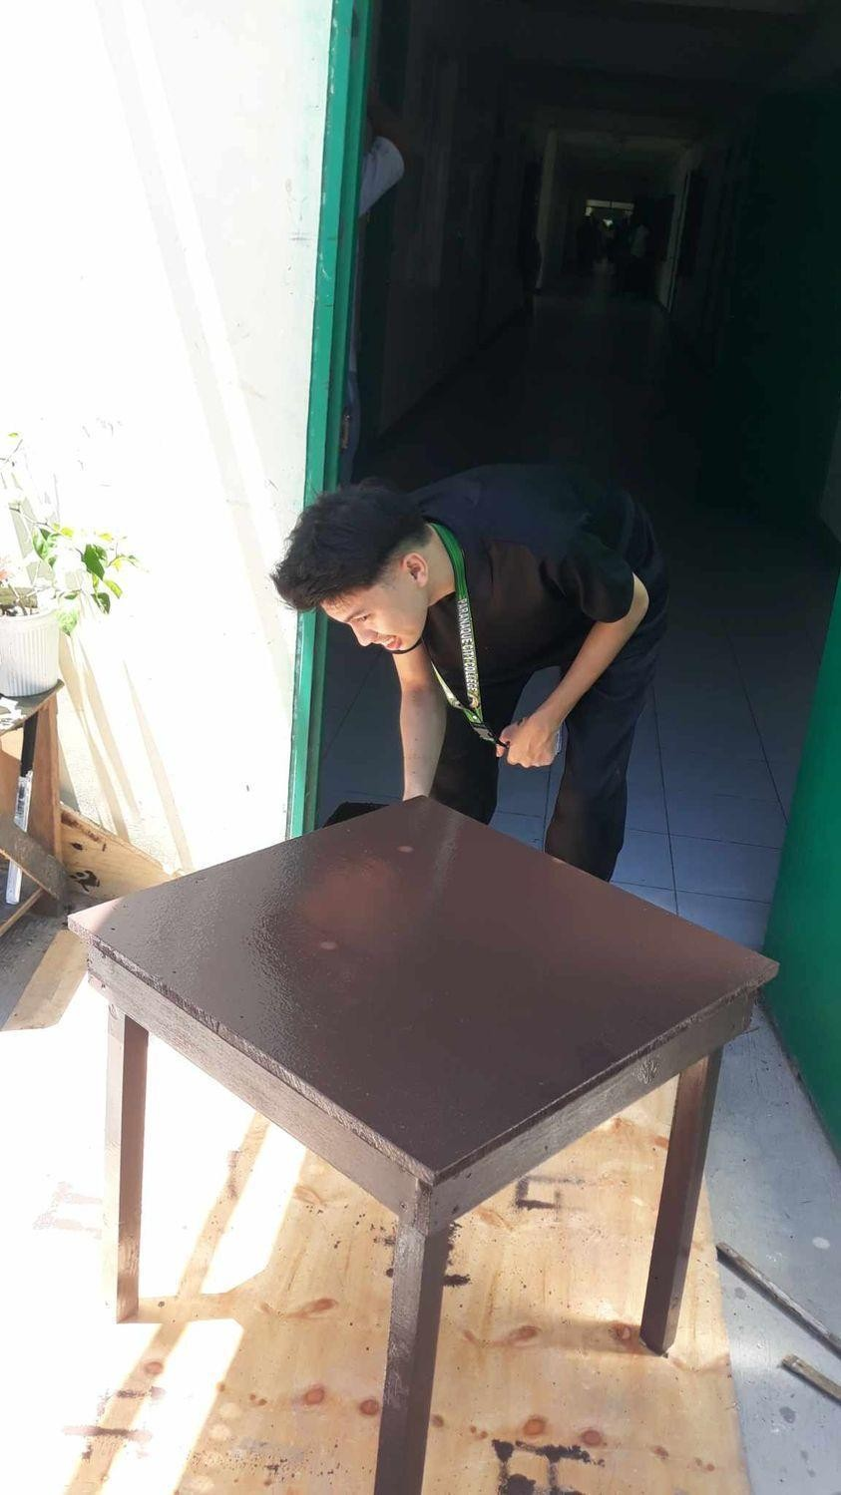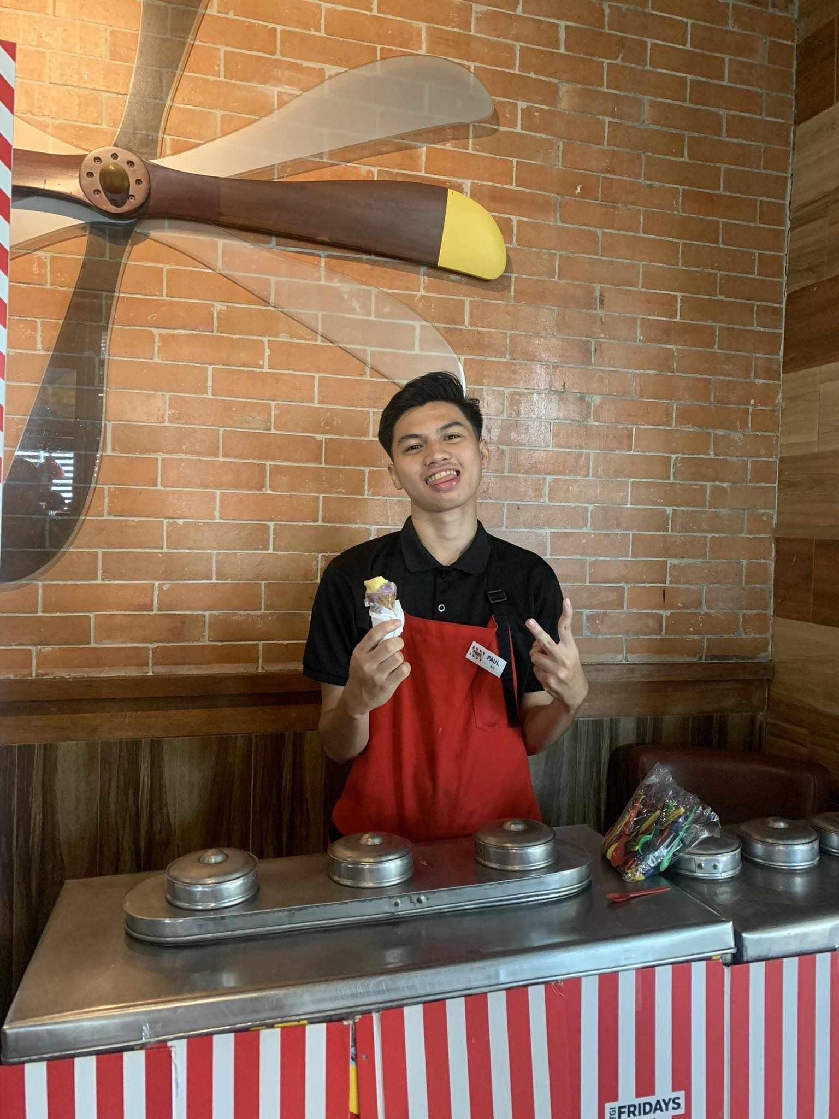

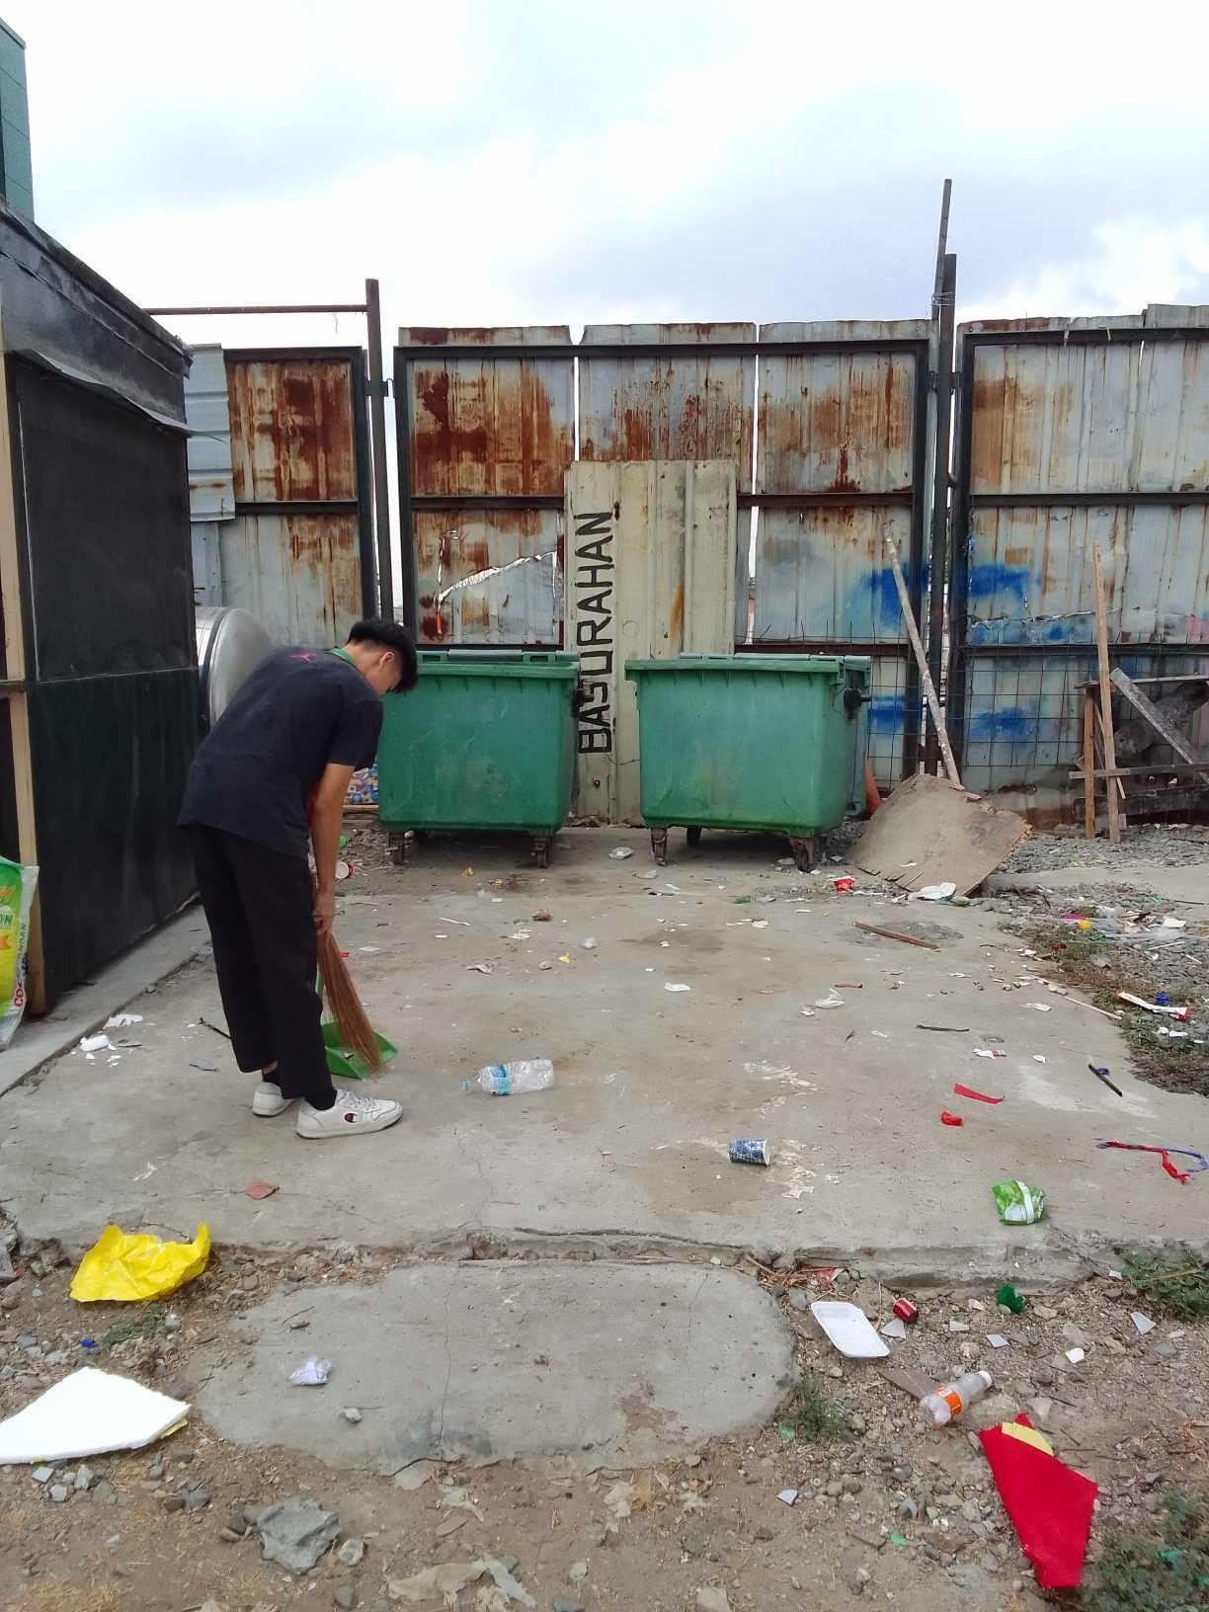

13

### Pre-Internship Requirements

* + 1. Certificate of Undertaking & Affidavit of Undertaking
    2. Updated Certificate of Grades and/or Evaluation Form
    3. Certificate of Registration/Enrollment Form
    4. Photocopy of School I.D
    5. PSA Birth Certificate/Marriage Contract (Married Women students)
    6. Parent/Guardian/Spouse Consent Form
    7. Medical Certificate (Issued by School Clinic)
    8. Practicum Recommendation Letter

1. **Certificate of Undertaking & Affidavit of Undertaking**
2. **Updated Certificate of Grades and/or Evaluation Form**

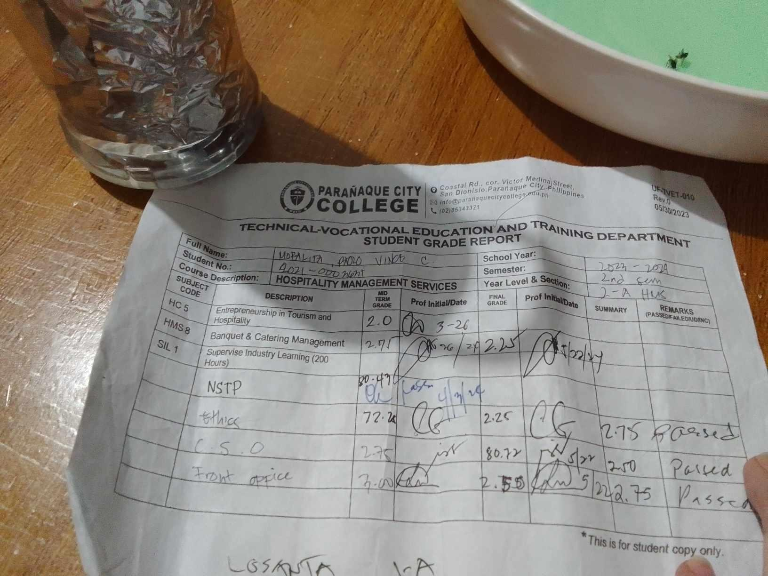

1. **Certificate of Registration/Enrollment Form**

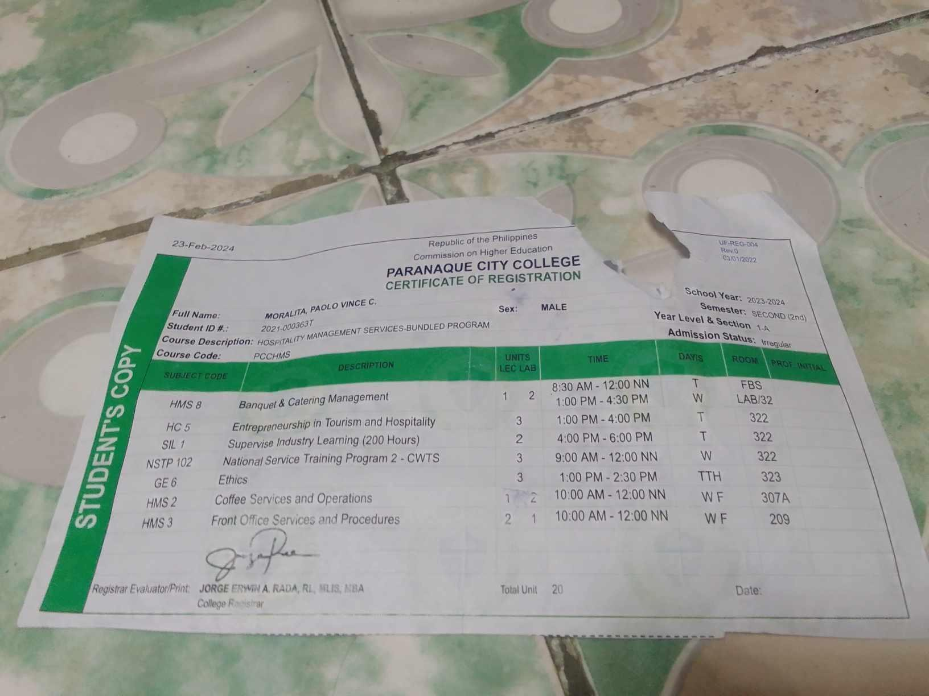

1. **Photocopy of School I.D**

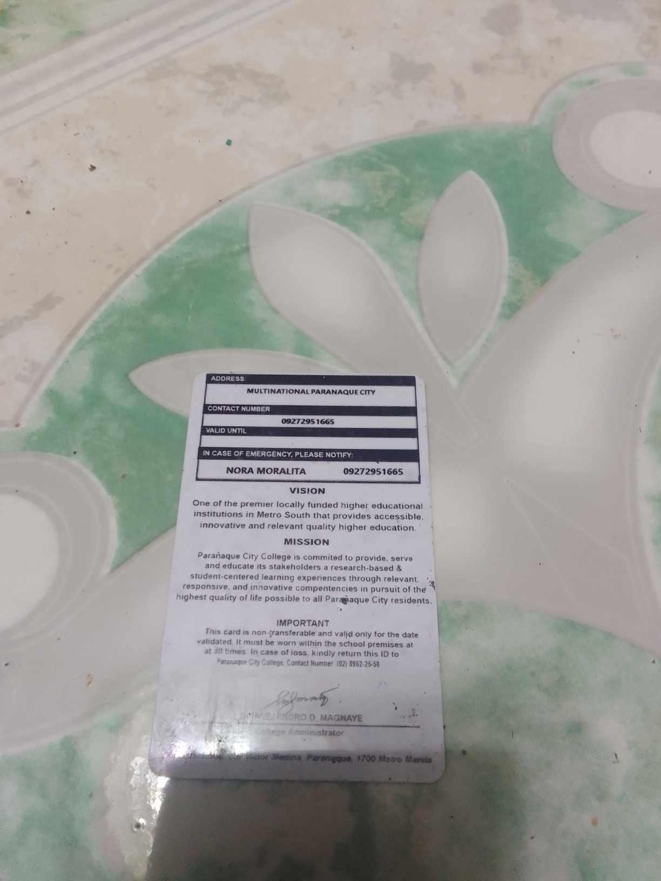

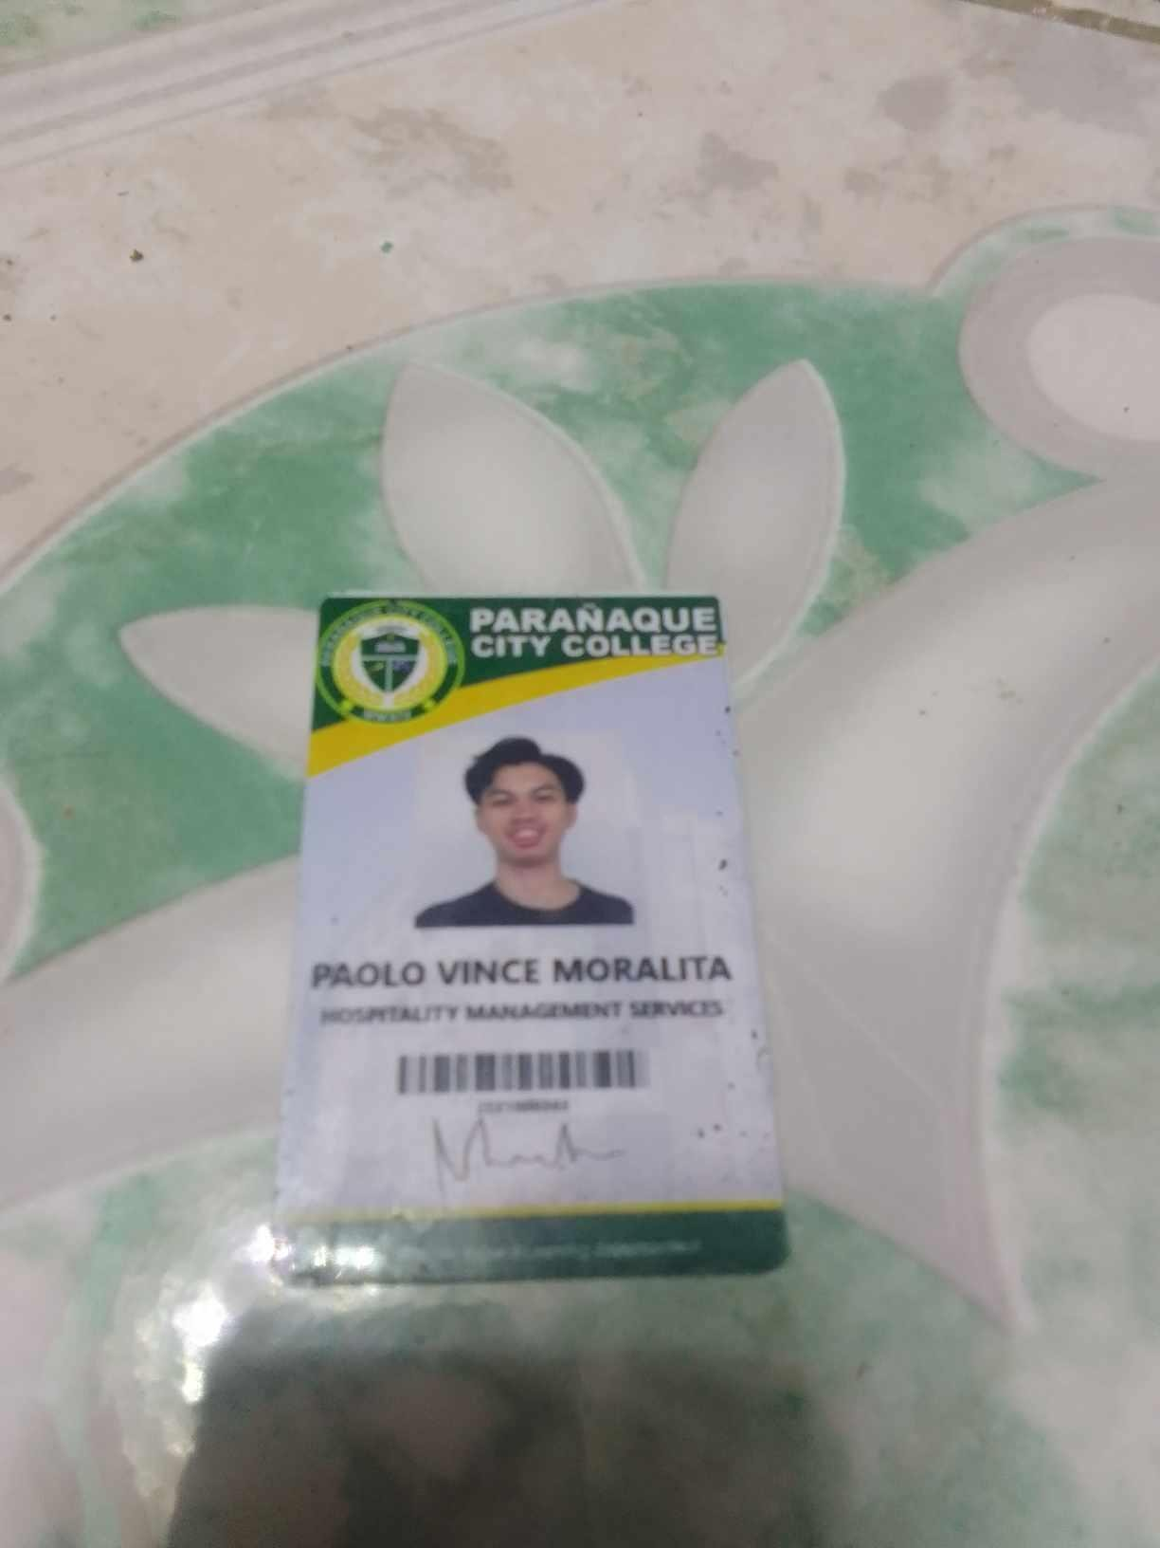

17

### PSA Birth Certificate/Marriage Contract (Married Women students)

18

1. **Parent/Guardian/Spouse Consent Form**
2. **Medical Certificate (Issued by School Clinic)**
3. **Practicum Recommendation Letter**

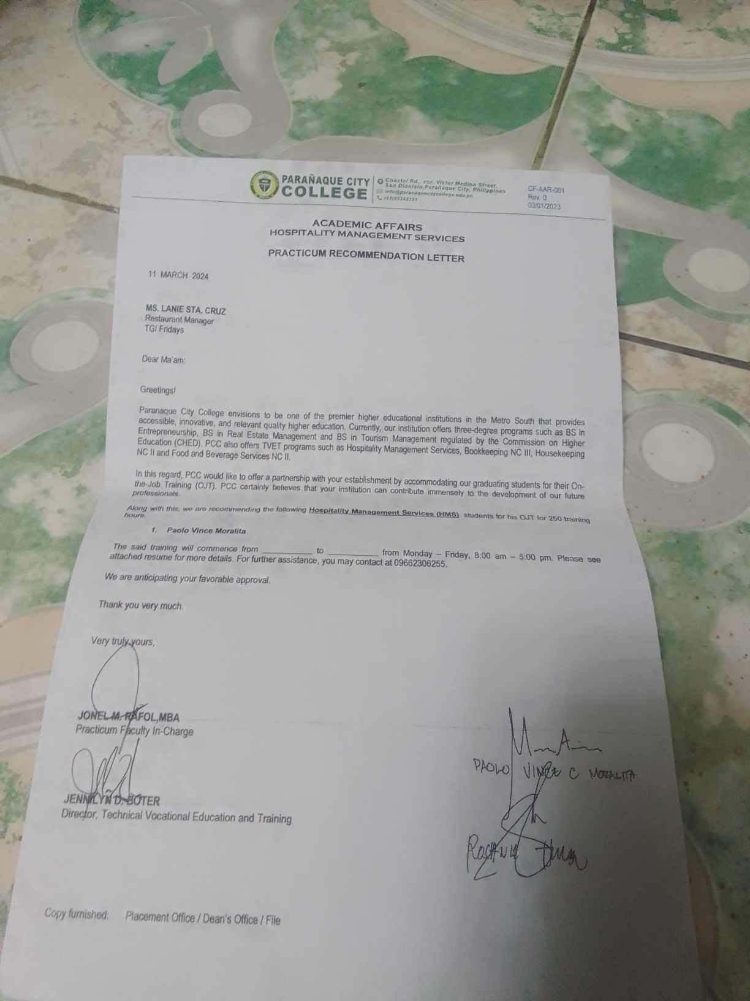

21

OFFICE OF THE ADMISSION, PLACEMENT AND ALUMNI

# PRACTICUM WEEKLY REPORT

(Once a week meeting with Practicum Faculty-in-charge)

Name of Student: MORALITA PAOLO VINCE Industry Partner: TGI’S FRIDAYS BAR AND GRILL Period Covered:

Area Assigned: F&B - FOOD AND BEVERAGES Week Number: 1st WEEK

|  |  |  |  |
| --- | --- | --- | --- |
| **DAY** | **DUTIES** | **TASKS** | **LEARNING OUTCOME** |
| Day 1 | **SEARCHING FOR INTERNSHIP** | **Seeking for a place to submit an internship application** | **I discovered that locating places for us to do an internship is challenging** |
| Day 2 | **INQUIRY FOR TGI’S FRIDAYS BAR AND GRILL** | **MADE AN INQUIRY FOR TGI’S FRIDAYS BAR**  **AND GRILL** | **I made an inquiry at TGI’S FRIDAYS BAR AND**  **GRILL and applied for an internship** |
| Day 3 | **INTERVIEW** | **Interview at TGI’S FRIDAYS BAR AND GRILL** | **They acknowledged my acceptance as an intern and proceeded all the**  **documents that I needed to submit to complete my internship application** |
| Day 4 | **COMPLETING REQUIREMENTS** | **I comply to our requirements** | **One by one, I accomplish each of the requirements** |

22

|  |  |  |  |
| --- | --- | --- | --- |
| Day 5 | **COMPLETING REQUIREMENTS** | **Comply to process our Recommendation Letter and MOA** | **I've completed all the requirements to**  **process our MOA and recommendation letter** |
| Day 6 | **COMPLETING REQUIREMENTS** | **Requesting for Medical Certification** | **I received my Medical Certification** |
| Day 7 | **COMPLETING REQUIREMENTS** | **I have received all necessary**  **requirements** | **I got the MOA and recommendation letter.** |

### OBSERVATIONS: (written by your supervisor)

.

### COMMENTS & SUGGESTIONS: (written by your supervisor)

**MORALITA, PAOLO VINCE C** Student Trainee **MAAM LANIE STA CRUZ** Supervisor In-Charge

## JONEL RAFOL

Practicum Adviser In-Charge Date:

23

# PRACTICUM WEEKLY REPORT

(Once a week meeting with Practicum Faculty-in-charge)

Name of Student: MORALITA PAOLO VINCE Industry Partner: TGI’S FRIDAYS BAR AND GRILL Period Covered:

Area Assigned: F&B - FOOD AND BEVERAGES Week Number: 2nd WEEK

|  |  |  |  |
| --- | --- | --- | --- |
| **DAY** | **DUTIES** | **TASKS** | **LEARNING OUTCOME** |
| Day 1 | **ORIENTATION** | **FAMILIARIZE THE TASKS** | **YOU HAVE TO BE AWARE OF WHAT'S GOING ON** |
| Day 2 | **ONSITE CLASS** | **STUDY BANQUET SERVICE** | **LEARNED THE DIFFERENTS TYPES OF BANQUET SERVICE** |
| Day 3 | **ONSITE CLASS** | **DISCUSSIONS** | **STUDY ABOUT NSTP** |

|  |  |  |  |
| --- | --- | --- | --- |
| Day 4 | **ONSITE CLASS** | **MAKING ESPRESSO** | **MAKING ESPRESSO** |

24

|  |  |  |  |
| --- | --- | --- | --- |
| Day 5 | **START OF MY INTERNSHIP AT TGI’S FRIDAYS BAR AND GRILL** | **FAMILIARIZE** | **I HAVE TO KNOW THE TABLE NUMBERS** |
| Day 6 | **MEMORIZING MENU** | **MEMORIZE MENU** | **WE HAVE TO BE FAMILIAR WITH THE**  **MENU** |
| Day 7 | **CLEANING AND SETTING UP TABLES** | **SET UP TABLES** | **CLEANING AND SETTING UP TABLES** |

### OBSERVATIONS: (written by your supervisor)

.

### COMMENTS & SUGGESTIONS: (written by your supervisor)

**MORALITA, PAOLO VINCE C** Student Trainee **MAAM LANIE STA CRUZ** Supervisor In-Charge

**JONEL RAFOL** Practicum Adviser In-Charge Date:

25

# PRACTICUM WEEKLY REPORT

(Once a week meeting with Practicum Faculty-in-charge)

Name of Student: MORALITA PAOLO VINCE Industry Partner: TGI’S FRIDAYS BAR AND GRILL Period Covered:

Area Assigned: F&B - FOOD AND BEVERAGES Week Number: 3rd WEEK

|  |  |  |  |
| --- | --- | --- | --- |
| **DAY** | **DUTIES** | **TASKS** | **LEARNING OUTCOME** |
| Day 1 | **FRONT DOOR** | **SITTING THE GUEST** | **COUNTING THE**  **NUMBER OF GUEST AND SITTING THE GUEST** |
| Day 2 | **ONSITE CLASS** | **STUDY OF BEING ENTREPRENEUR** | **LEARNING TO BE A GOOD OWNER AND EXPANDING YOUR BUSINESS** |

|  |  |  |  |
| --- | --- | --- | --- |
| Day 3 | **ONSITE CLASS** | **DISCUSSIONS** | **STUDY ABOUT NSTP AND BANQUET SERVICE** |
| Day 4 | **ONSITE CLASS** | **FRONT OFFICE** | **ROLEPLAY ABOUT FRONT OFFICE** |

26

|  |  |  |  |
| --- | --- | --- | --- |
| Day 5 | **ONSITE CLASS** | **MAKING COLD BEVERAGES** | **MAKING ICE COFFEE** |
| Day 6 | **BAR** | **CLEANING GLASSWARE IN THE BAR** | **you have to be gentle cleaning it, as it can easily be break** |
| Day 7 | **OPENING THE STORE** | **PREPARING ALL EQUIPMENTS BEFORE OPENING THE STORE** | **all equipments must be ready before the store opens** |

### OBSERVATIONS: (written by your supervisor)

.

### COMMENTS & SUGGESTIONS: (written by your supervisor)

**MORALITA, PAOLO VINCE C** Student Trainee Supervisor In-Charge

## JONEL RAFOL

Practicum Adviser In-Charge Date: August 16, 2023

27

# PRACTICUM WEEKLY REPORT

(Once a week meeting with Practicum Faculty-in-charge)

Name of Student: MORALITA PAOLO VINCE Industry Partner: PARANAQUE CITY COLLEGE Period Covered:

Area Assigned: HOUSEKEEPING Week Number: 4th WEEK

|  |  |  |  |
| --- | --- | --- | --- |
| **DAY** | **DUTIES** | **TASKS** | **LEARNING OUTCOME** |
| Day 1 | **Painting** | **Painting tables for library** | **Learning how to paint** |

|  |  |  |  |
| --- | --- | --- | --- |
| Day 2 | **Cleaning hallways** | **Making hallways clean and tidy** | **Cleaning hallways to make it appealing** |
| Day 3 | Cleaning parking lot area | **Making sure that the parking area is clean** | **Cleaning parking lot area to make it appealing** |

28

|  |  |  |  |
| --- | --- | --- | --- |
| Day 4 | **Cleaning rooms** | **Making sure that every room is clean** | **Cleaning rooms to make it appealing** |
| Day 5 | Taking out the trash | Making sure that all trash cans are not full | Keeping the area clean |
| Day 6 | Cleaning library | Making sure that library is clean | **Cleaning library to make it appealing** |
| Day 7 | Cleaning hallways | **Making hallways clean and tidy** | **Cleaning hallways to make it appealing** |

### OBSERVATIONS: (written by your supervisor)

.

### COMMENTS & SUGGESTIONS: (written by your supervisor)

**MORALITA, PAOLO VINCE C** Student Trainee Supervisor In-Charge

## JONEL RAFOL

Practicum Adviser In-Charge

29

## PRACTICUM DAILY TIME RECORD

**Name of Trainee:** MORALITA PAOLO VINCE

**Industry/Host Training Partner:** TGI’S FRIDAYS BAR AND GRILL/PARANAQUE CITY COLLEGE

|  |  |  |
| --- | --- | --- |
| **DATE** | **AREA OF RESPONSIBILITY** | **HOURS**  **COMPLETED** |
| MM/DD/YY |  | HOURS RENDERED |
| March 21, 2024 | DINING | 6 |
| March 22, 2024 | DINING | 6 |
| March 23, 2024 | DINING | 9 |
| March 24, 2024 | DINING | 8 |
| March 28, 2024 | DINING | 16 |
| March 29, 2024 | DINING | 16 |

|  |  |  |
| --- | --- | --- |
| March 30, 2024 | DINING | 8 |
| March 31, 2024 | DINING | 10 |
| May 7, 2024 | HOUSEKEEPING | 9 |
| May 8, 2024 | HOUSEKEEPING | 9 |
| May 9, 2024 | HOUSEKEEPING | 9 |
| May 10, 2024 | HOUSEKEEPING | 9 |
| May 13,, 2024 | HOUSEKEEPING | 9 |
| May 14, 2024 | HOUSEKEEPING | 9 |
| May 15, 2024 | HOUSEKEEPING | 9 |

30

|  |  |  |
| --- | --- | --- |
| May 16, 2024 | HOUSEKEEPING | 9 |
| May 17, 2024 | HOUSEKEEPING | 9 |
| May 18, 2024 | HOUSEKEEPING | 9 |
| May 20, 2024 | HOUSEKEEPING | 9 |
| May 22, 2024 | HOUSEKEEPING | 9 |
| May 22, 2024 | HOUSEKEEPING | 9 |
| May 23, 2024 | HOUSEKEEPING | 9 |
| May 24, 2024 | HOUSEKEEPING | 9 |
| May 25, 2024 | HOUSEKEEPING | 9 |
| May 22, 2024 | HOUSEKEEPING | 9 |
|  |  | Total: 200 hours |

31

ACADEMIC AFFAIRS

HOSPITALITY MANAGEMENT SERVICES

**PRACTICUM INCIDENT REPORT**

NAME: ___________________________________ PROGRAM & SECTION: _____________________

COMPANY NAME: _________________________ DATE OF INCIDENT: ______________

|  |
| --- |
| **Issues/Concerns/Complaints:**  Reported by the Manager of TGIF that Mr. Moralita and other practicum student from other institution has a conflict during their assigned schedule |
| **Action Taken:**  Called the Practicum Coordinator,  Sir Rafol called the Manager of the Restaurant |
| **Recommendation:**  The Restaurant final decision to removed the 2 involve trainees to avoid conflict and problems in their operations .  The Practicum adviser decided to continue the remaining hours at the Physical Plant Facilities Office which is related to the course taken by Mr. Moralita |

____________________ _________________________ _________________

**Student Practicum Faculty In-Charge Director, TVET**

32

OFFICE OF THE ADMISSION, PLACEMENT AND ALUMNI

## DAILY NARRATIVE JOURNAL REPORT WITH PHOTOS IN ACTION

**Name:** MORALITA PAOLO VINCE

**Date:**

**Name of Industry:** TGI FRIDAYS BAR AND GRILL/ PARANAQUE CITY COLLEGE

**Designation:** F&B/HOUSEKEEPING

Familiarizing Hotel facilities and polishing equipment For Restaurant

**Student Signature**:

Practicum Picture

**DATE:** MARCH 21 2024

Setting Up the Table and table ware

**DATE:** MARCH 22 2024

Memorizing a menu and Polishing Equipment For Restaurant

**DATE:** MARCH 23 2024

Taking Order and Preparing Table ware and Polishing Equipment for Restaurant

**DATE:** MARCH 24 2024

Setting Up the Table and table ware

33

**DATE:** MARCH 28 2024

Serving food and cleaning up tables and setting up tables

**DATE:** MARCH 29 2024

Helping cleaning glassware for the bar

**DATE:** MARCH 30 2024

Cleaning up tables

**DATE:** MARCH 31 2024

Serving food

**DATE:** MAY 7 2024

Cleaning hallways

**DATE:** MAY 8 2024

Cleaning parking lot area

**DATE:** MAY 9 2024

Cleaning library

34

**DATE:** MAY 10 2024

Cleaning rooms

**DATE:** MAY 11 2024

Cleaning facilities

**DATE:** MAY 13 2024

Cleaning rooms

**DATE:** MAY 14 2024

Cleaning parking loyt area

**DATE:** MAY 15 2024

Preparing Equipment for coming Event

**DATE:**MAY 16 2024

Cleaning facilities

35

**DATE:** MAY 17 2024

Cleaning library

**DATE:** MAY 18 2024

Cleaning facilities

**DATE:**MAY 20 2024

Cleaning hallways

**DATE:**MAY 22 2024

Cleaning parking lot area

36

## INDUSTRY PERFORMANCE EVALUATION FORM

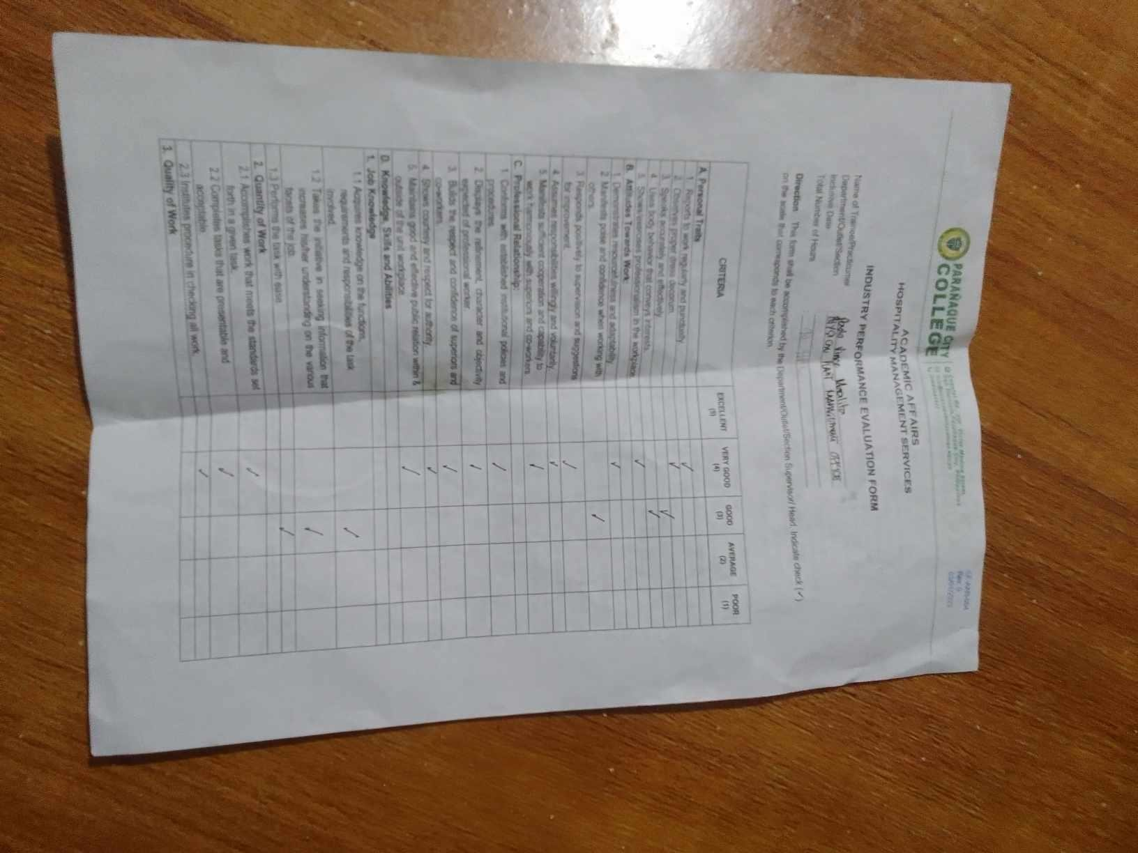

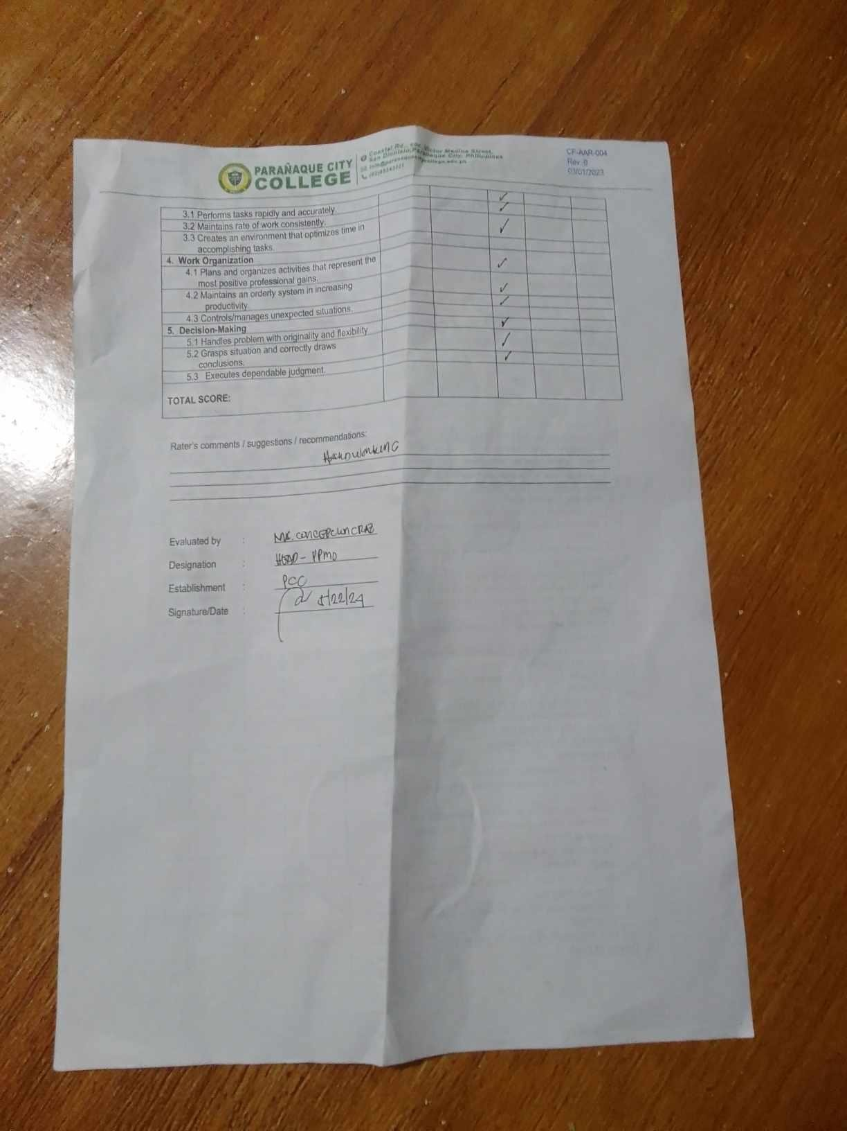

37

## INDUSTRY PERFORMANCE EVALUATION FORM

38

### Post Practicum Survey Form

Please answer the following as factually and accurately as possible.

1. Name of Trainee: Moralita Paolo Vince Date:
2. Industry/Host Training Partner: San Dionisio Credit Cooperative

2.1.1 Date Started: August 2, 2023 2.2 Date Finished: August 26, 2023 3. Profile:

3.1 Gender: Male 3.2 Date of Birth: December 27, 1999 3.3 Age: 24 3.2 3.4 Father’s/Guardian’s Name: VLADIMIR MORALITA Occupation: SEAMAN

3.5 Mother’s Name: ANGELITA MORALITA Occupation: N/A

1. Which subject have helped you much in doing your Practicum?

HMS4 FOOD & BEVERAGE SEVICES

1. List your expectation prior to deployment to this Practicum New Challenges, great Facilities, and Good Staff
2. Based on item No.5, indicate the expectation that you have met

All of them have met my expectation, good staff and friendly and also there facilities Are stunning and clean, and I met new Challenges like how to handle the guest and how to

take a order properly

1. Were you given orientation in school prior to development for Practicum? YES ✔ No

Do you find it sufficient? YES ✔ No

If NO, write specific topics/items that should have been included.

1. Were you given sufficient orientation on-site? YES ✔ No

If NO, list down what topics/items that should have been included.

_

_

1. What area’s in the establishment you were assigned?

39

RESTAURANT, , BAR, MEETING ROOMS

1. List down the outstanding/strong features of this industry/host training partner RESTAURANT,
2. List down the weak features, if any of the industry/host training partner.

N/A

1. Did you find yourself improved after the practicum? Why?

Yes, I learn a lot of things that need to improve on my skills

1. What skills have you learned from the practicum?

Multitasking, Organization, Communication

1. Do you think you have developed the competence to perform the tasks you undertook the practicum? Why?

Yes, because I learn a lot and focus on the training and develop my skills

1. What tips can you share with the students who will undergo practicum?

Stay humble, and Keep learning

1. Will you recommend the industry/host training partners to other students? Why?

Yes, Because of the features of the hotel and good staff

1. Which aspect of the Practicum did you enjoy most?

The most I enjoy in practicum is the hotel facilities and the staff are good they teach me all of the ways of how to serve properly and how to communicate with the guest

40

## CERTIFICATE OF COMPLETION

41

## D. CURRICULUM VITAE (CV)

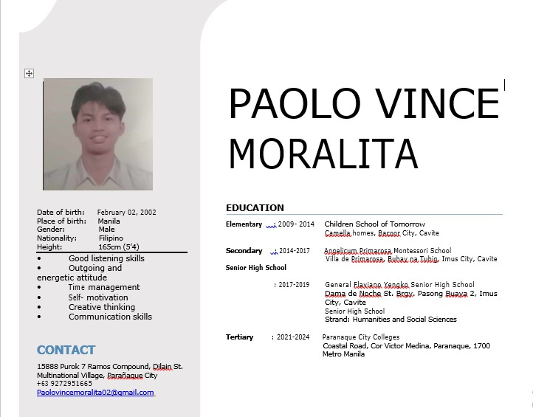

42